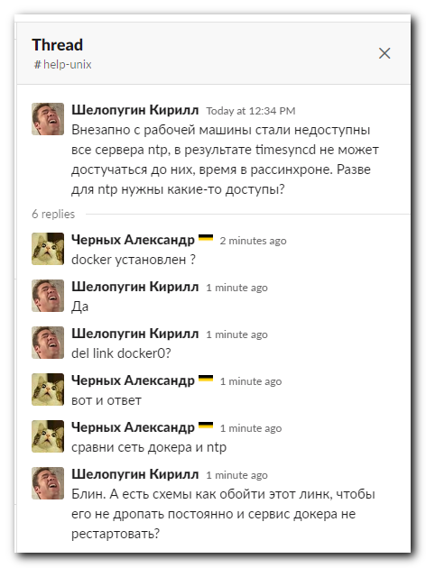

#
# 20200429
# On this server with Ubuntu 14.04 ntp does not work.
#
root@ds-bigdata-ub01p:/etc/apt# chronyc sourcestats
210 Number of sources = 6
Name/IP Address NP NR Span Frequency Freq Skew Offset Std Dev
==============================================================================
of-c1-lo0.tcsbank.ru 0 0 0 0.000 2000.000 +0ns 4000ms
dc-c1-lo0.tcsbank.ru 0 0 0 0.000 2000.000 +0ns 4000ms
dc-c2-lo0.tcsbank.ru 0 0 0 0.000 2000.000 +0ns 4000ms
ds-nx1-lo0.tcsbank.ru 0 0 0 0.000 2000.000 +0ns 4000ms
ds-nx2-lo0.tcsbank.ru 0 0 0 0.000 2000.000 +0ns 4000ms
of-c2-lo0.tcsbank.ru 0 0 0 0.000 2000.000 +0ns 4000ms
root@ds-bigdata-ub01p:/etc/apt#

root@ds-bigdata-ub01p:/etc/apt# chronyc tracking
Reference ID : 127.127.1.1 ()
Stratum : 10
Ref time (UTC) : Wed Apr 29 17:20:24 2020
System time : 0.000000000 seconds fast of NTP time
Last offset : 0.000000000 seconds
RMS offset : 0.000000000 seconds
Frequency : 4.320 ppm slow
Residual freq : 0.000 ppm
Skew : 0.000 ppm
Root delay : 0.000000 seconds
Root dispersion : 0.000001 seconds
Update interval : 0.0 seconds
Leap status : Not synchronised
root@ds-bigdata-ub01p:/etc/apt#

root@ds-bigdata-ub01p:/etc/apt# chronyc sources -v
210 Number of sources = 6

.-- Source mode '^' = server, '=' = peer, '#' = local clock.
/ .- Source state '*' = current synced, '+' = combined , '-' = not combined,
| / '?' = unreachable, 'x' = time may be in error, '~' = time too variable.
|| .- xxxx [ yyyy ] +/- zzzz
|| / xxxx = adjusted offset,
|| Log2(Polling interval) -. | yyyy = measured offset,
|| \ | zzzz = estimated error.
|| | |
MS Name/IP address Stratum Poll Reach LastRx Last sample
===============================================================================
^? of-c1-lo0.tcsbank.ru 0 8 0 10y +0ns[ +0ns] +/- 0ns
^? dc-c1-lo0.tcsbank.ru 0 8 0 10y +0ns[ +0ns] +/- 0ns
^? dc-c2-lo0.tcsbank.ru 0 8 0 10y +0ns[ +0ns] +/- 0ns
^? ds-nx1-lo0.tcsbank.ru 0 8 0 10y +0ns[ +0ns] +/- 0ns
^? ds-nx2-lo0.tcsbank.ru 0 8 0 10y +0ns[ +0ns] +/- 0ns
^? of-c2-lo0.tcsbank.ru 0 8 0 10y +0ns[ +0ns] +/- 0ns
root@ds-bigdata-ub01p:/etc/apt#

# I suppose - it’s not network permissions to connect to ntp servers.
root@ds-bigdata-ub01p:/etc/apt# ping -c 3 ntp01.tcsbank.ru
PING of-c1-lo0.tcsbank.ru (172.20.16.192) 56(84) bytes of data.
From 172.20.0.1 icmp_seq=1 Destination Host Unreachable
From 172.20.0.1 icmp_seq=2 Destination Host Unreachable
From 172.20.0.1 icmp_seq=3 Destination Host Unreachable

--- of-c1-lo0.tcsbank.ru ping statistics ---
3 packets transmitted, 0 received, +3 errors, 100% packet loss, time 2001ms
pipe 3
root@ds-bigdata-ub01p:/etc/apt#

# For example - here is ping available!
[root@m1-soc-ls1 ~]# ping -c 3 ntp01.tcsbank.ru
PING of-c1-lo0.tcsbank.ru (172.20.16.192) 56(84) bytes of data.
64 bytes from of-c1-lo0.tcsbank.ru (172.20.16.192): icmp_seq=1 ttl=249 time=1.76 ms
64 bytes from of-c1-lo0.tcsbank.ru (172.20.16.192): icmp_seq=2 ttl=249 time=1.65 ms
64 bytes from of-c1-lo0.tcsbank.ru (172.20.16.192): icmp_seq=3 ttl=249 time=1.81 ms

--- of-c1-lo0.tcsbank.ru ping statistics ---
3 packets transmitted, 3 received, 0% packet loss, time 2003ms
rtt min/avg/max/mdev = 1.659/1.746/1.815/0.081 ms
[root@m1-soc-ls1 ~]#

# I found rules in iptables for same sub-network, that used ntp-serves.
root@ds-bigdata-ub01p:/etc/apt# iptables -n -L -t filter ; iptables -n -L -t nat ; iptables -n -L -t mangle
...
Chain POSTROUTING (policy ACCEPT)
target prot opt source destination
MASQUERADE all -- 172.21.0.0/16 0.0.0.0/0
MASQUERADE all -- 172.20.0.0/16 0.0.0.0/0
MASQUERADE all -- 172.19.0.0/16 0.0.0.0/0
MASQUERADE all -- 172.18.0.0/16 0.0.0.0/0
MASQUERADE all -- 172.17.0.0/16 0.0.0.0/0
MASQUERADE tcp -- 172.19.0.2 172.19.0.2 tcp dpt:8002
MASQUERADE tcp -- 172.21.0.2 172.21.0.2 tcp dpt:8003
...

# I’ve collected info about iptables rules before “prune” command and after.
root@ds-bigdata-ub01p:/etc/apt# var1="$(date +%Y%m%d-%H%M).iptables.txt" ; iptables -n -L -t filter | tee -a ~/work/20200429-2039/${var1} ; iptables -n -L -t nat | tee -a ~
/work/20200429-2039/${var1} ; iptables -n -L -t mangle | tee -a ~/work/20200429-2039/${var1}

root@ds-bigdata-ub01p:/etc/apt# /usr/bin/docker network prune -f
Deleted Networks:
new_service_flask_30-03_default
service_flask_14-02_default

root@ds-bigdata-ub01p:/etc/apt#

# Let’s test.
root@ds-bigdata-ub01p:/etc/apt# chronyc sourcestats
210 Number of sources = 6
Name/IP Address NP NR Span Frequency Freq Skew Offset Std Dev
==============================================================================
of-c1-lo0.tcsbank.ru 0 0 0 0.000 2000.000 +0ns 4000ms
dc-c1-lo0.tcsbank.ru 0 0 0 0.000 2000.000 +0ns 4000ms
dc-c2-lo0.tcsbank.ru 0 0 0 0.000 2000.000 +0ns 4000ms
ds-nx1-lo0.tcsbank.ru 0 0 0 0.000 2000.000 +0ns 4000ms
ds-nx2-lo0.tcsbank.ru 0 0 0 0.000 2000.000 +0ns 4000ms
of-c2-lo0.tcsbank.ru 1 0 0 0.000 2000.000 +0ns 4000ms
root@ds-bigdata-ub01p:/etc/apt# service chrony restart
Restarting time daemon: Starting /usr/sbin/chronyd...
chronyd is running and online.
# Here I see exactly right result!
root@ds-bigdata-ub01p:/etc/apt# chronyc sourcestats
210 Number of sources = 6
Name/IP Address NP NR Span Frequency Freq Skew Offset Std Dev
==============================================================================
of-c1-lo0.tcsbank.ru 3 3 4 28.448 21903.061 -7998ns 76us
dc-c1-lo0.tcsbank.ru 3 3 4 25.596 17582.391 +2109us 66us
dc-c2-lo0.tcsbank.ru 3 3 4 31.260 18319.193 +283us 70us
ds-nx1-lo0.tcsbank.ru 3 3 4 22.370 17061.342 +386us 58us
ds-nx2-lo0.tcsbank.ru 3 3 4 148.105 214789 +359us 442us
of-c2-lo0.tcsbank.ru 4 3 54 4.710 39.653 +2208us 34us
root@ds-bigdata-ub01p:/etc/apt#

root@ds-bigdata-ub01p:/etc/apt# chronyc tracking
Reference ID : 172.20.16.192 (of-c1-lo0.tcsbank.ru)
Stratum : 3
Ref time (UTC) : Wed Apr 29 18:03:29 2020
System time : 0.000027679 seconds fast of NTP time
Last offset : 0.000014815 seconds
RMS offset : 0.000219079 seconds
Frequency : 2.348 ppm slow
Residual freq : 0.008 ppm
Skew : 0.171 ppm
Root delay : 0.003970 seconds
Root dispersion : 0.010073 seconds
Update interval : 129.4 seconds
Leap status : Normal
root@ds-bigdata-ub01p:/etc/apt#

root@ds-bigdata-ub01p:/etc/apt# chronyc sources -v
210 Number of sources = 6

.-- Source mode '^' = server, '=' = peer, '#' = local clock.
/ .- Source state '*' = current synced, '+' = combined , '-' = not combined,
| / '?' = unreachable, 'x' = time may be in error, '~' = time too variable.
|| .- xxxx [ yyyy ] +/- zzzz
|| / xxxx = adjusted offset,
|| Log2(Polling interval) -. | yyyy = measured offset,
|| \ | zzzz = estimated error.
|| | |
MS Name/IP address Stratum Poll Reach LastRx Last sample
===============================================================================
^* of-c1-lo0.tcsbank.ru 2 7 377 83 -294us[ -279us] +/- 12ms
^- dc-c1-lo0.tcsbank.ru 2 6 377 82 +1829us[+1829us] +/- 27ms
^+ dc-c2-lo0.tcsbank.ru 2 7 377 16 -33us[ -33us] +/- 14ms
^+ ds-nx1-lo0.tcsbank.ru 3 6 377 17 +194us[ +194us] +/- 19ms
^+ ds-nx2-lo0.tcsbank.ru 3 6 377 18 +259us[ +259us] +/- 17ms
^- of-c2-lo0.tcsbank.ru 3 7 377 82 +1888us[+1888us] +/- 41ms
root@ds-bigdata-ub01p:/etc/apt#

# Here a difference. The problem line was removed.
root@ds-bigdata-ub01p:/etc/apt# diff -Nuar ~/work/20200429-2039/20200429-2043.iptables.txt ~/work/20200429-2039/20200429-2046.iptables.txt
--- /root/work/20200429-2039/20200429-2043.iptables.txt 2020-04-29 20:43:40.987815969 +0300
+++ /root/work/20200429-2039/20200429-2046.iptables.txt 2020-04-29 20:46:35.996563845 +0300
@@ -16,19 +16,11 @@
ACCEPT all -- 0.0.0.0/0 0.0.0.0/0 ctstate RELATED,ESTABLISHED
ACCEPT all -- 0.0.0.0/0 0.0.0.0/0
ACCEPT all -- 0.0.0.0/0 0.0.0.0/0
-DOCKER all -- 0.0.0.0/0 0.0.0.0/0
-ACCEPT all -- 0.0.0.0/0 0.0.0.0/0 ctstate RELATED,ESTABLISHED
-ACCEPT all -- 0.0.0.0/0 0.0.0.0/0
-ACCEPT all -- 0.0.0.0/0 0.0.0.0/0
-DOCKER all -- 0.0.0.0/0 0.0.0.0/0
-ACCEPT all -- 0.0.0.0/0 0.0.0.0/0 ctstate RELATED,ESTABLISHED
-ACCEPT all -- 0.0.0.0/0 0.0.0.0/0
-ACCEPT all -- 0.0.0.0/0 0.0.0.0/0

Chain OUTPUT (policy ACCEPT)
target prot opt source destination

-Chain DOCKER (5 references)
+Chain DOCKER (3 references)
target prot opt source destination
ACCEPT tcp -- 0.0.0.0/0 172.19.0.2 tcp dpt:8002
ACCEPT tcp -- 0.0.0.0/0 172.21.0.2 tcp dpt:8003
@@ -41,20 +33,6 @@
DROP all -- 0.0.0.0/0 0.0.0.0/0
DROP all -- 0.0.0.0/0 0.0.0.0/0
DROP all -- 0.0.0.0/0 0.0.0.0/0
-DROP all -- 0.0.0.0/0 0.0.0.0/0
-DROP all -- 0.0.0.0/0 0.0.0.0/0
-DROP all -- 0.0.0.0/0 0.0.0.0/0
-DROP all -- 0.0.0.0/0 0.0.0.0/0
-DROP all -- 0.0.0.0/0 0.0.0.0/0
-DROP all -- 0.0.0.0/0 0.0.0.0/0
-DROP all -- 0.0.0.0/0 0.0.0.0/0
-DROP all -- 0.0.0.0/0 0.0.0.0/0
-DROP all -- 0.0.0.0/0 0.0.0.0/0
-DROP all -- 0.0.0.0/0 0.0.0.0/0
-DROP all -- 0.0.0.0/0 0.0.0.0/0
-DROP all -- 0.0.0.0/0 0.0.0.0/0
-DROP all -- 0.0.0.0/0 0.0.0.0/0
-DROP all -- 0.0.0.0/0 0.0.0.0/0
RETURN all -- 0.0.0.0/0 0.0.0.0/0
Chain PREROUTING (policy ACCEPT)
target prot opt source destination
@@ -70,9 +48,7 @@
Chain POSTROUTING (policy ACCEPT)
target prot opt source destination
MASQUERADE all -- 172.21.0.0/16 0.0.0.0/0
-MASQUERADE all -- 172.20.0.0/16 0.0.0.0/0
MASQUERADE all -- 172.19.0.0/16 0.0.0.0/0
-MASQUERADE all -- 172.18.0.0/16 0.0.0.0/0
MASQUERADE all -- 172.17.0.0/16 0.0.0.0/0
MASQUERADE tcp -- 172.19.0.2 172.19.0.2 tcp dpt:8002
MASQUERADE tcp -- 172.21.0.2 172.21.0.2 tcp dpt:8003

@@ -82,8 +58,6 @@
RETURN all -- 0.0.0.0/0 0.0.0.0/0
RETURN all -- 0.0.0.0/0 0.0.0.0/0
RETURN all -- 0.0.0.0/0 0.0.0.0/0
-RETURN all -- 0.0.0.0/0 0.0.0.0/0
-RETURN all -- 0.0.0.0/0 0.0.0.0/0
DNAT tcp -- 0.0.0.0/0 0.0.0.0/0 tcp dpt:8002 to:172.19.0.2:8002
DNAT tcp -- 0.0.0.0/0 0.0.0.0/0 tcp dpt:8003 to:172.21.0.2:8003
Chain PREROUTING (policy ACCEPT)
root@ds-bigdata-ub01p:/etc/apt#

#
# 20200604
# SD#4079738
#
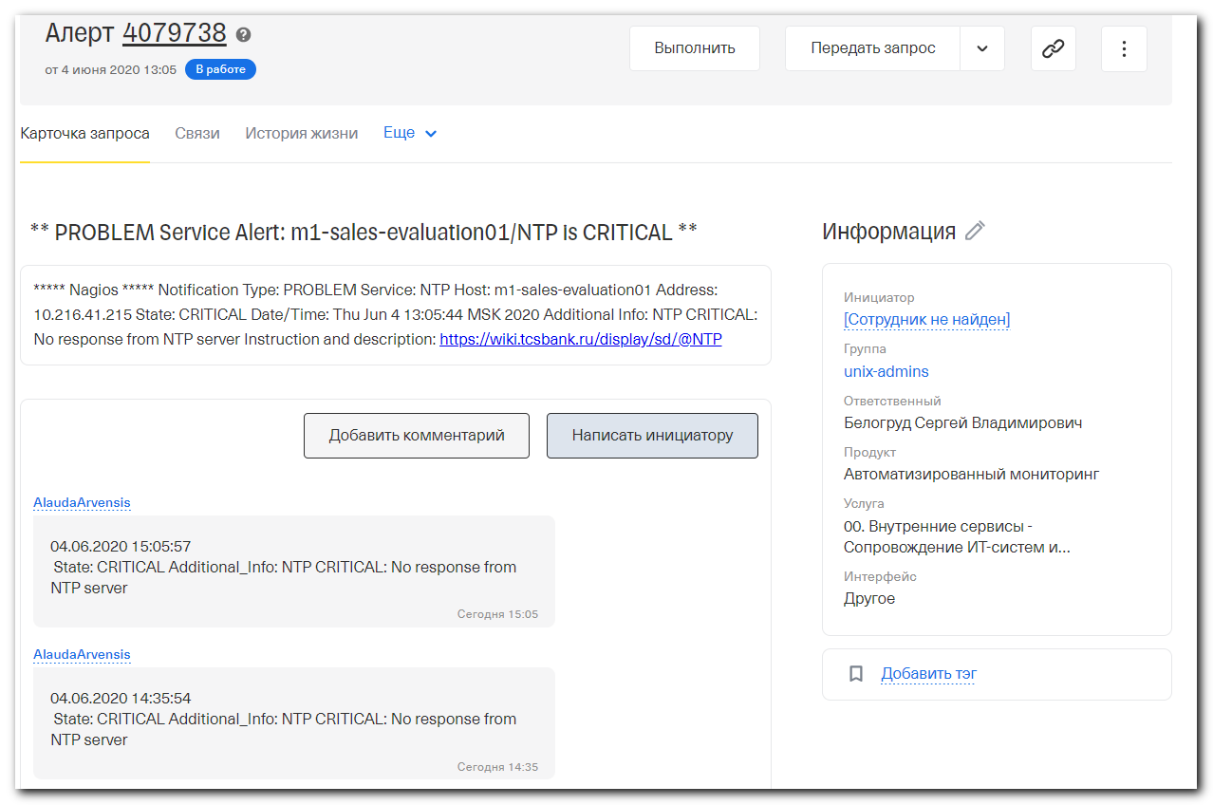

root@m1-sales-evaluation01:~# systemctl status ntp
● ntp.service - LSB: Start NTP daemon
Loaded: loaded (/etc/init.d/ntp; bad; vendor preset: enabled)
Active: active (running) since Fri 2020-01-24 03:45:11 EST; 4 months 10 days ago
Docs: man:systemd-sysv-generator(8)
Tasks: 1
Memory: 2.1M
CPU: 10min 58.801s
CGroup: /system.slice/ntp.service
└─24997 /usr/sbin/ntpd -p /var/run/ntpd.pid -g -u 114:119

Jun 04 07:39:02 m1-sales-evaluation01.tcsbank.ru ntpd[24997]: 172.20.16.193 local addr 10.216.41.215 -> 172.19.0.1
Jun 04 07:39:02 m1-sales-evaluation01.tcsbank.ru ntpd[24997]: 172.20.16.192 local addr 10.216.41.215 -> 172.19.0.1
Jun 04 07:39:02 m1-sales-evaluation01.tcsbank.ru ntpd[24997]: new interface(s) found: waking up resolver
Jun 04 07:39:07 m1-sales-evaluation01.tcsbank.ru ntpd[24997]: Deleting interface #21 br-351f03c93d83, 172.19.0.1#123, interface stats: received=0, sent=6, dropped=0, active_time=5 sec
Jun 04 07:39:07 m1-sales-evaluation01.tcsbank.ru ntpd[24997]: 172.20.16.192 local addr 172.19.0.1 -> <null>
Jun 04 07:39:07 m1-sales-evaluation01.tcsbank.ru ntpd[24997]: 172.20.16.193 local addr 172.19.0.1 -> <null>
Jun 04 07:39:07 m1-sales-evaluation01.tcsbank.ru ntpd[24997]: 172.20.16.194 local addr 172.19.0.1 -> <null>
Jun 04 07:39:07 m1-sales-evaluation01.tcsbank.ru ntpd[24997]: 172.20.16.205 local addr 172.19.0.1 -> <null>
Jun 04 07:39:07 m1-sales-evaluation01.tcsbank.ru ntpd[24997]: 172.20.16.206 local addr 172.19.0.1 -> <null>
Jun 04 07:39:07 m1-sales-evaluation01.tcsbank.ru ntpd[24997]: 172.20.16.197 local addr 172.19.0.1 -> <null>
root@m1-sales-evaluation01:~#

root@m1-sales-evaluation01:~# ntpq -nc pe
remote refid st t when poll reach delay offset jitter
==============================================================================
172.20.16.192 .XFAC. 16 u 206m 1024 0 0.000 0.000 0.000
172.20.16.193 .XFAC. 16 u 217m 1024 0 0.000 0.000 0.000
172.20.16.194 .XFAC. 16 u 191m 1024 0 0.000 0.000 0.000
172.20.16.205 .XFAC. 16 u 190m 1024 0 0.000 0.000 0.000
172.20.16.206 .XFAC. 16 u 196m 1024 0 0.000 0.000 0.000
172.20.16.197 .XFAC. 16 u 206m 1024 0 0.000 0.000 0.000
root@m1-sales-evaluation01:~# ip a | grep -w inet
inet 127.0.0.1/8 scope host lo
inet 10.216.41.215/24 brd 10.216.41.255 scope global eth0
inet 172.17.0.1/16 brd 172.17.255.255 scope global docker0
inet 172.18.0.1/16 brd 172.18.255.255 scope global br-35ef3fecbc65
inet 172.19.0.1/16 brd 172.19.255.255 scope global br-351f03c93d83
inet 172.20.0.1/16 brd 172.20.255.255 scope global br-41bd574a79a8
inet 172.21.0.1/16 brd 172.21.255.255 scope global br-cc6f635a4bb2
root@m1-sales-evaluation01:~#

root@m1-sales-evaluation01:~# /usr/bin/docker network prune -f
Deleted Networks:
aopichugin_default
aopichugin_graylog
graylog_default
graylog_graylog

root@m1-sales-evaluation01:~#

root@m1-sales-evaluation01:~# ip a | grep -w inet
inet 127.0.0.1/8 scope host lo
inet 10.216.41.215/24 brd 10.216.41.255 scope global eth0
inet 172.17.0.1/16 brd 172.17.255.255 scope global docker0
root@m1-sales-evaluation01:~#

root@m1-sales-evaluation01:~# systemctl restart ntp
root@m1-sales-evaluation01:~# ntpq -nc pe
remote refid st t when poll reach delay offset jitter
==============================================================================
172.20.16.192 192.36.143.130 2 u - 64 1 0.957 0.423 0.200
172.20.16.193 91.209.94.10 2 u - 64 1 0.646 -0.521 0.184
172.20.16.194 192.36.143.130 2 u - 64 1 1.111 0.141 0.000
172.20.16.205 172.20.16.193 3 u - 64 1 1.817 -0.437 0.204
172.20.16.206 172.20.16.193 3 u 1 64 1 2.207 -0.174 0.000
172.20.16.197 172.20.16.193 3 u 1 64 1 1.535 -0.026 0.000
root@m1-sales-evaluation01:~#

